
ITRI 613
Project Documentation

Muhle Mabunda
39928454

Contents
1. Introduction 2
2. UML Component Diagram. 2
2.1 Components 2
2.2 UML Diagram 3
3.1. Endpoints 3
3.2. Patterns Used 4
3.3. Tools 4
3.4. Data simulation 4
4. Screenshots 5
Power BI Dashboard 5
Page 1: Dashboard Siummary 5
Page 2: Buildings Insight 5
Page 3: Room Monitoring 6
5. Azure Components: 7
Stream Analytics Jobs Query 8
5.3 python scripts 9
6. Conclusion 10

1. Introduction
Modern university campuses contain many rooms such as classrooms, laboratories, lecture halls, and offices that need continuous monitoring to ensure they remain safe, comfortable, and efficient for students and staff. In this project, each room is treated as a monitored smart space where live sensor data is collected, including temperature, humidity, air quality, occupancy, motion, and electricity usage. Traditional manual inspections or delayed reports are often too slow, meaning problems such as overcrowding, poor ventilation, or wasted energy may only be identified after they have already caused disruption.
This project proposes a Smart Campus Real-Time Room Monitoring System that uses stream processing to analyse room conditions continuously as data is generated. Real-time processing is more effective than batch processing because alerts can be triggered immediately when unsafe or inefficient conditions occur, such as high temperatures, poor air quality, empty rooms using electricity, or rooms exceeding occupancy limits. The system also helps answer key operational questions such as which rooms currently need attention, which buildings use the most energy, and how room usage changes throughout the day. Azure Event Hubs, Stream Analytics, Cosmos DB, and Power BI are used together to provide live dashboards and faster decision-making for campus management.

2. UML Component Diagram.

2.1 Components
- Sensor Data Generator (Python Producer)
Simulates IoT sensors and continuously generates room data such as temperature, humidity, occupancy, motion, and electricity usage.
- Azure Event Hub
Receives incoming streaming events from the Python producer and acts as the ingestion layer.
- Azure Stream Analytics Job
Processes incoming events in real time, applies filtering and business logic, and prepares structured outputs.
- Azure Cosmos DB
Stores processed sensor records in a scalable NoSQL database for historical analysis and reporting.
- Power BI Dashboard
Connects to Cosmos DB and displays live dashboards across three pages:
- Dashboard summary
- Building Insights
- Rooms Monitoring

2.2 UML Diagram

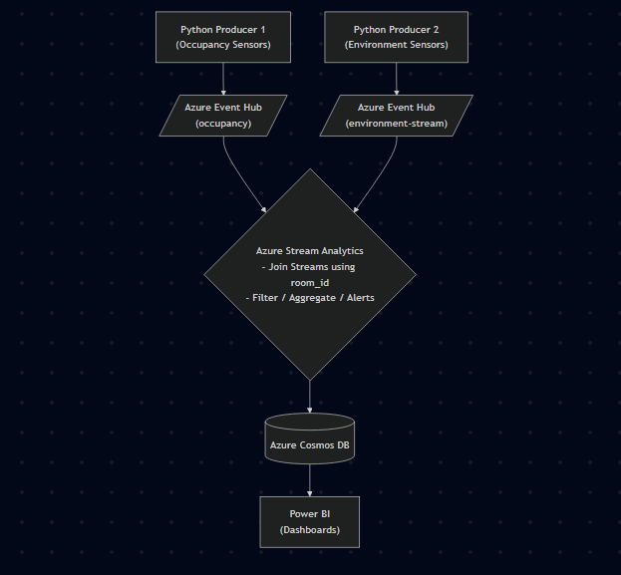

3.1. Endpoints
Python Producers (Occupancy & Environment):
- Uses the EventHub to stream real-time sensor data (temperature, humidity, occupancy, electricity usage) into two separate Event Hub instances: occupancy and environment-stream.
Azure Stream Analytics:
- Acting as the processing engine, it consumes the two streams, performs a join operation using room_id, and outputs the structured results directly to an Azure Cosmos DB container.
Power BI:
- Connects to the data source using the Power BI Cosmos DB SQL API v1 connector, allowing the dashboard to refresh visuals as new sensor records are stored.

3.2. Patterns Used
Database Service:
- In this architecture, the Stream Analytics job is the exclusive writer to the Cosmos DB, while Power BI acts as the reader.

3.3. Tools
- Azure Event Hub:
- Azure Stream Analytics:
- Azure Cosmos DB:
- Power BI:
- Python 3.10+:

3.4. Data simulation
Data is generated using Python-based simulation scripts that act as virtual IoT devices. This ensures the pipeline can be tested under realistic load conditions and varying environmental scenarios.
How the Simulation Works:
Synthetic Data Generation: The simulation uses Python’s random and time libraries to generate data points within realistic physical ranges (e.g., temperatures between 18°C and 35°C, or occupancy counts from 0 to 100).
Streaming: the scripts run in an infinite loop sending a new JSON packet to the Azure Event Hub every few seconds.
The simulation is programmed to create events of interest, such as a sudden spike in temperature or a room being occupied after hours, to verify that the Azure Stream Analytics logic correctly triggers alerts.

4. Screenshots

Power BI Dashboard

Page 1: Dashboard Siummary

This is the Executive View"of the entire campus. It provides a snapshot of overall performance using key metrics (KPIs) like the total number of active alerts, average campus-wide temperature, and current total occupancy. It is designed for management to quickly see if any major issues require immediate attention without getting bogged down in the details.

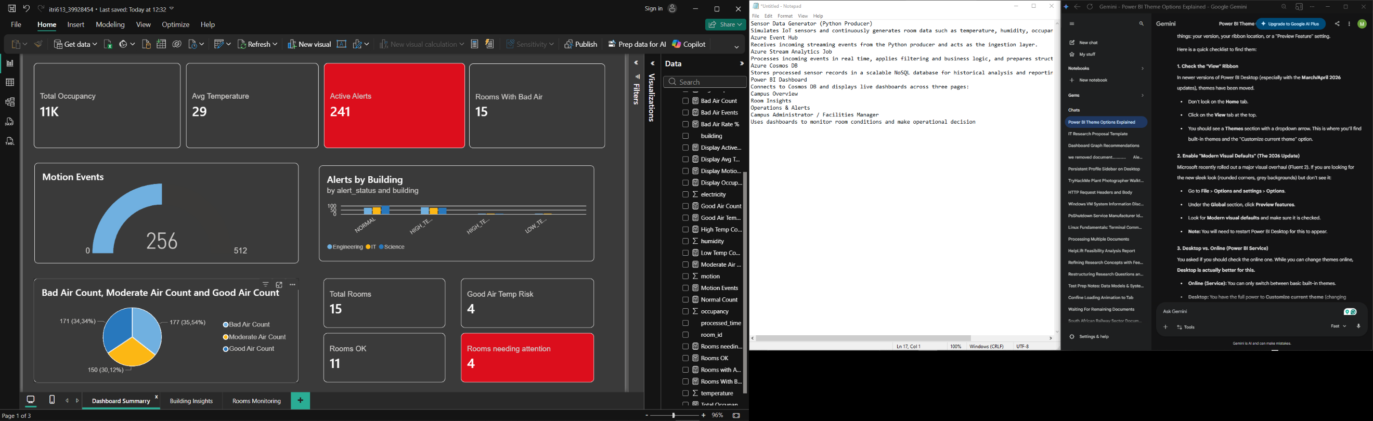

Page 2: Buildings Insight
This page moves from the campus level to the building level. It allows for a direct comparison between different structures (for example, comparing the Engineering building to the Science labs). This view is particularly useful for identifying patterns, such as which buildings are consuming the most electricity or which ones are consistently overcrowded, helping to improve campus-wide resource planning.
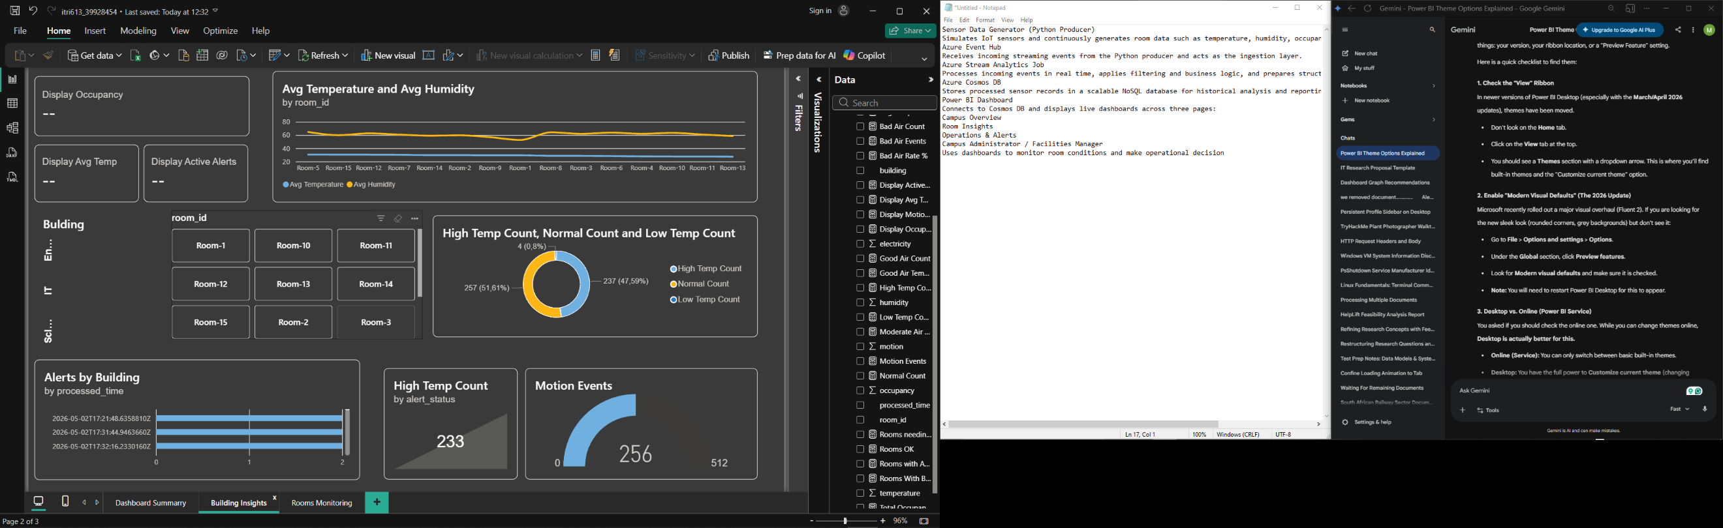

Page 3: Room Monitoring
The final page provides the most granular level of detail. It is a dedicated space for monitoring individual rooms or specific laboratories. Here, you can see live real-time data for a single room,including exact temperature, humidity levels, and motion detection. If the system triggers a specific alert such as a High Temperature warning this is the page staff would use to investigate exactly what is happening in that specific location

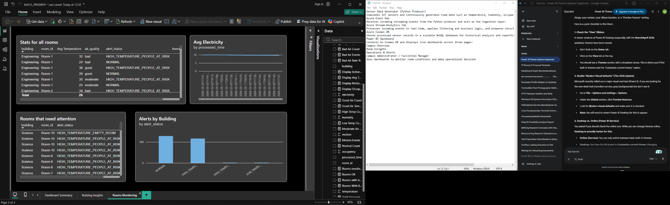

5. Azure Components:
The Azure pipeline is a real-time stream processing architecture designed to continuously ingest, analyze, and store campus sensor data. The pipeline flows through the following Azure components:

Azure Event Hub: Acts as the entry point, receiving continuous streams of raw IoT sensor data (temperature, humidity, motion, occupancy, etc.) sent by Python producers into two separate hubs: occupancy and environment-stream.
Azure Stream Analytics: Consumes the incoming events from both Event Hubs in real time. It uses a SQL-like query to join the environment and occupancy streams together based on room_id and applies business logic to generate specific alert_status conditions (e.g., flagging a room as HIGH_TEMPERATURE_EMPTY_ROOM).
Azure Cosmos DB: The Stream Analytics job writes the combined and evaluated structured records directly into this scalable NoSQL database container for storage and historical reporting.

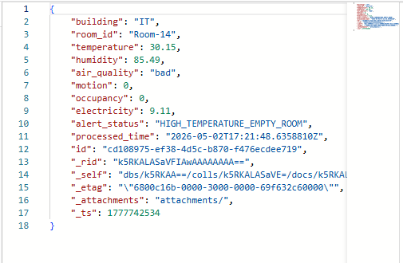

Stream Analytics Jobs Query

“SELECT
e.building,
e.room_id,

e.temperature,
e.humidity,
e.air_quality,

o.motion,
o.occupancy,
o.electricity,

CASE
WHEN e.temperature > 30 AND o.occupancy > 0
THEN 'HIGH_TEMPERATURE_PEOPLE_AT_RISK'

WHEN e.temperature > 30 AND o.occupancy = 0
THEN 'HIGH_TEMPERATURE_EMPTY_ROOM'

WHEN e.temperature < 18 AND o.occupancy > 0
THEN 'LOW_TEMPERATURE_PEOPLE_DISCOMFORT'

WHEN e.temperature < 18 AND o.occupancy = 0
THEN 'LOW_TEMPERATURE_EMPTY_ROOM'

ELSE 'NORMAL'
END AS alert_status,

System.Timestamp() AS processed_time

INTO cosmosOutput

FROM environmentInput e TIMESTAMP BY event_time

JOIN occupancyInput o TIMESTAMP BY event_time

ON e.room_id = o.room_id
AND e.building = o.building
AND DATEDIFF(second, e, o) BETWEEN -5 AND 5
“

5.3 python scripts
Occupancy stream script:

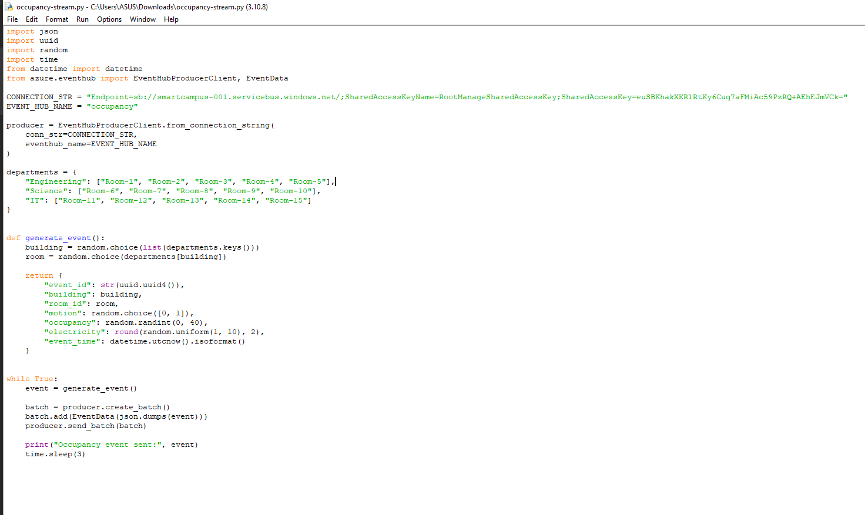

Environment stream:

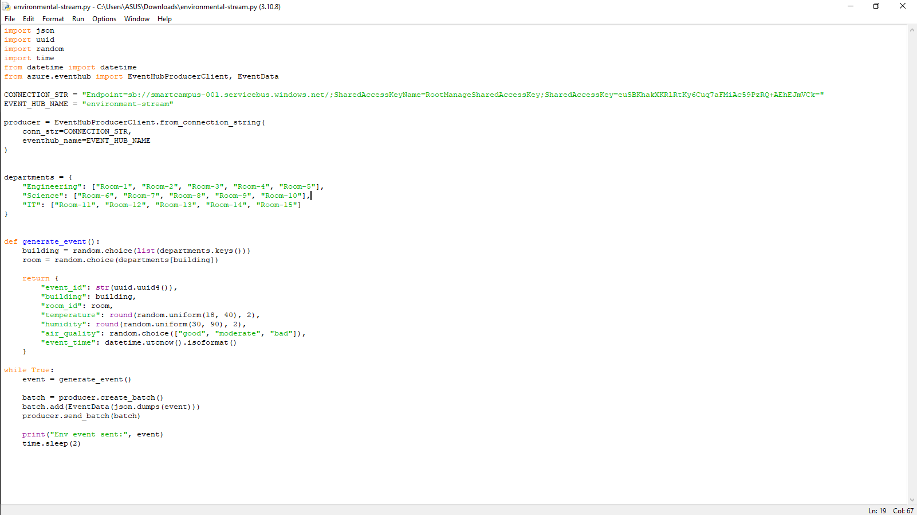

6. Conclusion

In conclusion, the Smart Campus project shows how real-time technology can make a university much easier to manage. Instead of relying on slow manual checks, we used Azure to create a system that monitors rooms as things happen. This allows campus management to fix problems like wasted energy in empty rooms or poor air quality immediately.

By using Cosmos DB and Power BI, we’ve created a clear way for staff to see exactly how the campus is running at any moment. Ultimately, this project proves that using live data is a practical and professional way to save resources, reduce costs, and make the campus a safer, more comfortable place for both students and staff.

